VOLTA CL Electronic Speed Controller

Instruction Manual Firmware Version 2.07
The VOLTA CL product line represents advanced speed controllers for use exclusively in airplane models. With integrated telemetry and various possibilities of optional user configuration, the controllers offer high efficiency, low weight and precise motor control.

Features
- Small dimensions combined with high power motor control.
- Over- and undervoltage protection, overtemperature protection, motor-stall protection.
- Configurable current limiter.
- Fast and precise heli/governor mode with many configuration possibilities.
- Small linear BEC 8V/150mA for powering additional devices, such as telemetry receiver (servo operation NOT supported).
- Safety shutdown when the throttle impulse is lost.
- Configurable acceleration, timing, electromagnetic brake, motor reversing etc.
- Low acoustic noise due to high frequency switching.
- Automatic telemetry detection: Duplex EX, Hott, MSB, PowerBox P²Bus, S.Bus2.
- Telemetry (RC system dependent): voltage, current, power, capacity, temperature, RPM, energy.
- Telemetry min/max values are logged.
- Configuration through the transmitter, MAV Manager PC software or external terminal (JETIBOX).
- Firmware updates via USB interface.
- Languages: CZ/DE/EN/FR/IT.

 | VOLTA 20CL
Dimensions | 19 x 28 x 5mm
Weight incl. cables | 8,5 g
Continuous current | 25A
Peak current | 50A/2s
Supply voltage | 6 – 24V
LiPo cells | 2 – 5
LiFe cells | 3 – 6
Battery/motor cables | 1mm²/0.75mm²
Anti-spark circuit | No
Recommended connectors | XT30, MR30
Temperature range | -10÷110°C
PWM frequency | 20kHz
Operating current | 30mA
Standby current | 4mA
Propeller positioning | No
Telemetry | Duplex EX, Multiplex MSB, Futaba S.Bus2, Graupner Hott, PowerBox P²Bus, FrSky
Status LED | Yes
Active Freewheeling | Yes
BEC | 8V/150mA (not for servos)
Optical isolation | No
Maximum RPM | > 300 000 eRPM (2-pole motor)

Warning: Never connect a load to the BEC output that exceeds the limits specified in this manual. The stabilized voltage output is intended only for powering the JETIBOX or an external telemetry-capable receiver. It must not be used to supply servos.
The controller is equipped with a linear voltage regulator. This means that the available output power decreases as the input voltage increases.
Note: The controller may be used with a 6S LiPo battery pack (maximum 26 V) only if the following conditions are met:
- An additional Low-ESR capacitor of approximately 220 µF is soldered directly to the ESC supply cables.
- No external load is connected to the BEC output.

Installation
Fasten the controller in your model using Velcro or double-sided adhesive tape. Connect the motor and receiver according to the schematic below. You may connect the motor cables in arbitrary order, as changing direction is done by exchanging any of the two cables (alternatively also by the “Direction” parameter in the configuration). Turn on the transmitter followed by the receiver – by plugging in the main flight pack.
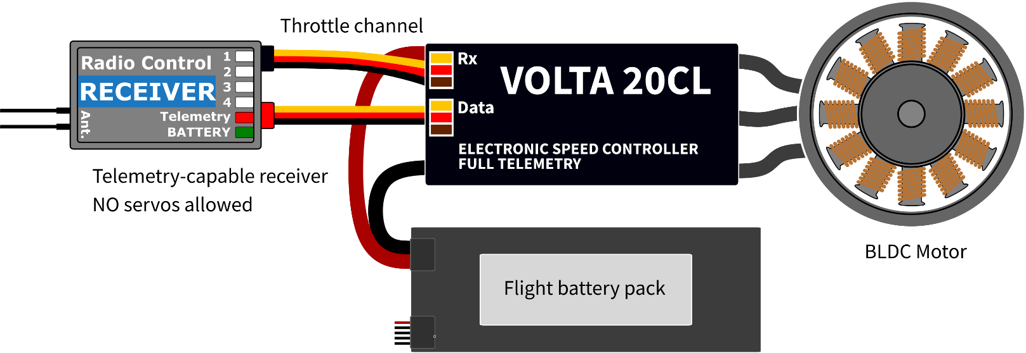
Note: The red LED on the controller will light up for two seconds to indicate proper initialization. After the correct throttle impulse is detected (meaning off position), the controller plays a predefined melody. Now it’s ready to fly. If the throttle impulse is not detected for more than 4 seconds (e.g. after disconnecting the receiver battery), the controller will enter standby mode.
Warning: Always use brand new, high quality connectors and make sure that the cables are soldered perfectly. Any possibility of losing connection during motor run represents a risk of damaging your electronics.
Warning: If you start the controller for the first time, or make any significant changes in the setup, please make sure that the propeller is removed from the motor shaft.
Warning: Always disconnect batteries after the flight session ends. Even if the speed controller is turned off by the switch, it still draws some small current. This could result in a completely drained battery within a few days or weeks.

Controller mode
It is possible to choose from several basic controller modes:
- Normal (ramped) – the preconfigured acceleration time is always applied when accelerating. This is a default mode for major use.
- Fast mode – the preconfigured acceleration is applied only when spinning up from zero revolutions. After that, a minimum possible delay is used (0.2s for zero-to-full throttle response).
- Heli/Governor – fast and precise control of constant Rpm with many adjustable parameters.
- Bidirectional – motor direction and power are controlled by a single channel. This is a standard car/boat mode.
- Line Timer Automatic – this is the option for the control line flight, the controller automatically follows a preprogrammed RPM curve without any interventions from the receiver.

Throttle input signal
The controller expects positive impulses from the receiver with maximum refresh rate up to 400Hz. By default, with automatic endpoints selected, the controller will work with vast majority of RC systems. In such case, a minimum throttle impulse is read after startup and the maximum power is dynamically adjusted as soon as you apply full throttle for the first time.
In case you need exact points on your transmitter stick, where the motor starts and where full throttle is, you can configure manual endpoints as well.
Note: The controller waits for throttle-low position after startup and also every time the motor is stopped due to any error condition. If the throttle stick is not at the correct position during startup, the ESC plays a warning tone.

Motor settings
It is possible to configure many of the motor parameters, including acceleration, timing, motor gear ratio or number of poles. The gear ratio and number of poles are important for telemetry to measure the motor speed correctly.
Acceleration influences the motor response on the throttle channel. By decreasing the acceleration value, the motor response gets faster, providing more “locked-in” feeling. However, the motor consumes more current and the controller generates more heat. We recommend the default acceleration 1.0s for majority of model types, including electric gliders, scale models, EDFs etc. For 3D aerobatic flight you might go down to 0.5s or even less (with care). For the fastest motor response, you may also set the “Fast controller mode” in the Common Settings.
Timing is defined by the motor type and it is usually recommended by the motor manufacturer. It also influences the motor power and current consumption. Higher timing can increase the motor power but care must be taken not to overload the system.
- Automatic timing: The timing is continuously adjusted by the internal algorithm. This is a universal solution compatible with most motor types.
- Timing 0° - 10°: Recommended for inrunners.
- Timing 15° - 20°: Recommended for most outrunners. It offers good power and efficiency combination.
- Timing 25° - 30°: The high torque motors with many poles require the highest timing.
Motor type should be modified only in some specific cases where it is necessary by the application. There are three options available:
- “Standard” motor type – recommended for most motor types and applications.

Startup power influences the first few motor revolutions. If you are not satisfied with the automatic mode, you can set the motor start to be more aggressive (positive values), or as smooth as possible (negative values).

Brake configuration
The electromagnetic brake is a standard feature of all ESCs used in electric glider models. The VOLTA CL controller offers several additional parameters to fine tune the braking function. You can use one of the preconfigured brake settings, or you can specify all the parameters as you wish.
Brake options:
- Off: The propeller spins freely without braking.
- Soft: Transition from zero to full braking force in 1.0s.
- Medium: Transition to full braking force in 0.7s.
- Hard: Transition from 50% to 100% braking force in 0.5s.
- Manual: You can specify all brake parameters manually:
  - Start power – braking force applied from the first moment of applying the brake.
  - End power – braking force applied after the transition time elapses (usually the full braking force that stops the motor completely).
  - Transition – time between brake start power and brake end power. During this time, the braking force continuously transits from start to end power.
  - Wait time – time between unpowering the motor and applying the brake. During this time the motor spins freely without power.
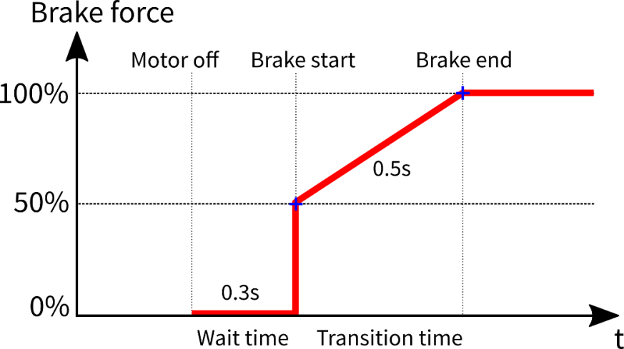 | Example: Motor brake with the following parameters: Start power = 50%, End power = 100%, Transition = 0.5s, Wait time = 0.3s.

Active freewheeling
“Active freewheeling” or “Active braking” is a feature of the speed controller that reduces heat generated by the ESC during partial load operation. This mode is useful for aerobatic pilots who want not only fast acceleration, but also rapid deceleration. The motor follows throttle stick input in both ways and the pilot feels more “locked-in”.

Current limiter
The current limiter is a part of safety controller features. It doesn’t stop the motor but rather continuously monitors the immediate current consumption and adjusts the motor power. You can enable this feature, specify the maximum allowed current and the ESC will reduce the motor power immediately as soon as the current threshold is exceeded. After the current returns back to the safe level, the motor power is restored.

Battery protection
The integrated battery protection is based on undervoltage detection and reducing motor power, alternatively shutting down the motor completely. You are free to set the number of cells (or leave automatic detection) and low voltage threshold per cell. Supported battery types are NiXX (1.2V), LiFe (3.6V max) and LiIo/LiPo (4.2V max).

Status codes
The status codes are shown on the screen (JETIBOX) if any kind of error condition occurs. If any status code is set, the red LED continuously flashes.
Available status codes:
- Low voltage (UL): The battery voltage got below the threshold specified in the battery protection menu and the controller either reduced the maximum power, or shut down the motor completely.
- High voltage (UH): In case you use a weak battery or wall power supply, the voltage might rise above the initial level during braking. In such case the alarm is set and all braking functions are disabled.
- High current (IH): The current got higher than the maximum peak current defined in the product specification.
- High temperature (T100, T110, T120): The temperature got above the safety threshold level. The numerical value specifies maximum detected temperature and safety protocol which has been applied.
- Commutation error (COM): A synchronization error has been detected during the motor operation. It usually occurs when the motor stops abruptly, or in case of very fast acceleration for some specific setups. This error could mean a serious issue in the motor-controller installation.
- Overcurrent stop (IM): The motor has been stopped due to an enormous current flowing through the circuit, preventing further damage.

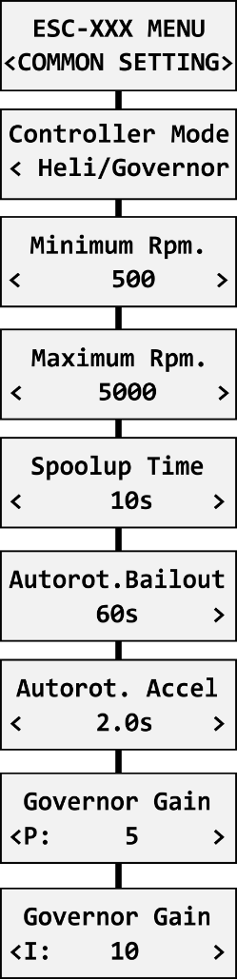
Heli/Governor mode
The speed controllers contain a fast and precise governor function. You are able to configure the governor mode in many aspects according to your preferences.
Before enabling the governor mode, please make sure the blades are removed. In the Common Setting menu, set the Controller Mode to “Heli/Governor” and proceed through the settings below:
- Set the minimum and maximum RPM of the main rotor according to your preferences. As soon as you move the throttle away from idle position, the controller slowly spools up until it reaches the target speed. The speed is calculated according to the throttle channel value, where low throttle corresponds to the “Minimum Rpm” and high throttle corresponds to “Maximum Rpm.”
- Set the Spoolup Time to make the motor startups as smooth as possible. You may set the time up to 60s. The spoolup time is applied when the motor starts from zero revolutions or if the autorotation bailout is disabled.
- Configure the Autorotation bailout time and autorotation acceleration time. The autorotation bailout function is used in case you need to quickly exit the autorotation and prevent your model from crashing. In this case, as soon as you move the throttle channel away from idle position, the “Autorotation acceleration” will be used to spin the motor until it reaches the required speed. The “Autorotation bailout” parameter sets the time after switching off the motor, where the autorotation bailout function may be activated. After exceeding this time, a standard spool-up time will be applied.
- Advanced setting: Governor gains – (P)roportional and (I)ntegral. You may modify the gains to fine tune the controller response to fast changes in the load during flight maneuvers. Please perform the changes only in small steps and verify the resulting behavior in a short test flight.
  - Increase the P gain to eliminate small Rpm fluctuations during straight flight, e.g. while hovering. If you hear some unexpected noise in the motor/gearbox (which means fast oscillations), reduce the P gain by 20%.
  - Increase the I gain to hold the precise revolutions during maneuvers. If the motor speed starts to oscillate noticeably, reduce the I gain by 20%.
- In the Governor mode, manual throttle endpoints are always used (by default 1.1ms – 1.9ms) and Active braking is enabled as well.
The picture below shows RPM response vs. throttle position. In this case, default throttle endpoints have been used (1.1ms – 1.9ms).
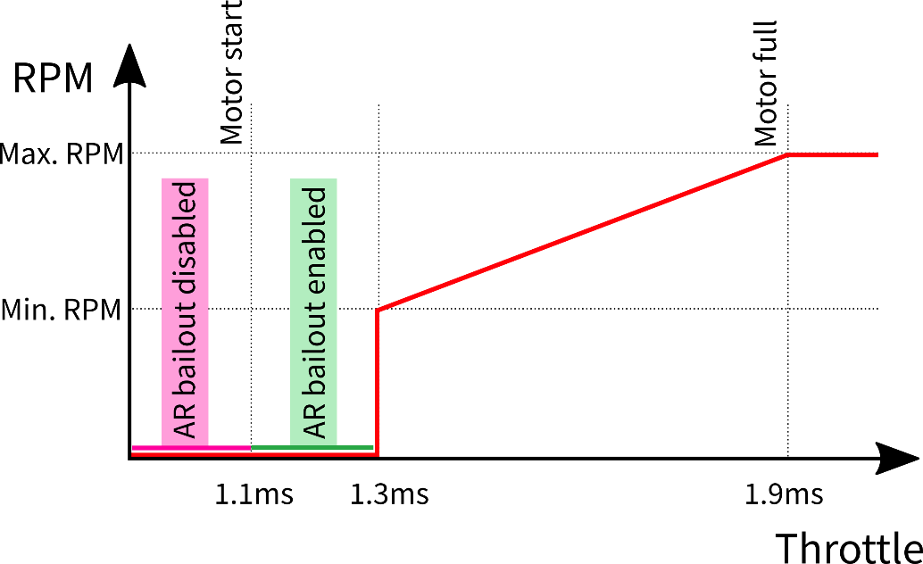
Note: Please make sure the gear ratio and number of motor poles are correctly set in the Motor Setting menu. Also, please verify that the brake is disabled and check the state of the propeller positioning function.

Please note that dynamic changes of the motor revolutions in flight are limited by the “Acceleration” parameter configured in the Motor Setting menu. Please make sure the acceleration is slow enough, so that changing revolutions in flight does not lead to sudden changes in model attitude.
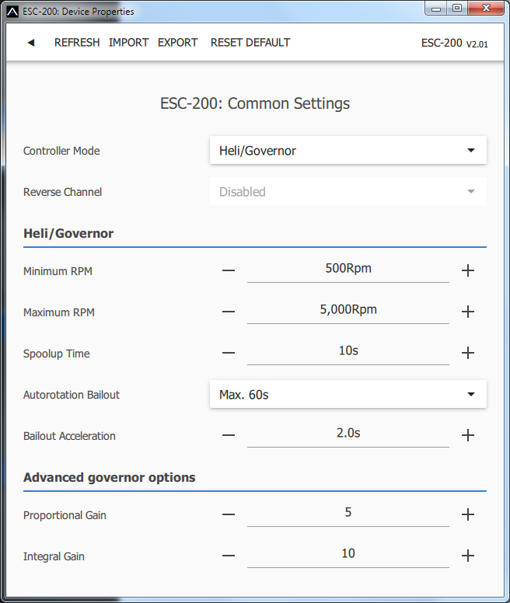

Motor direction reversing – Bidirectional mode
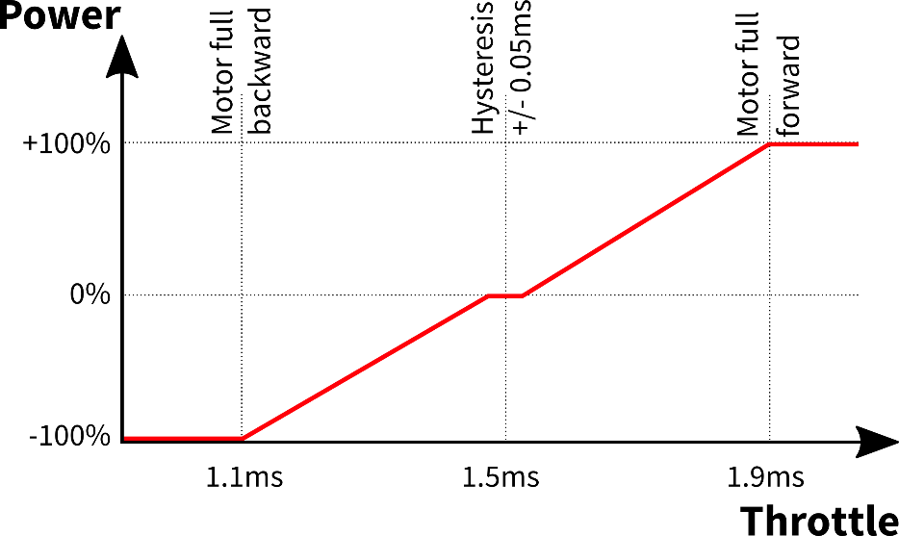
By setting the controller mode to "Bidirectional," you can enable the standard bidirectional operation commonly used in car or boat models. Before initialization, the controller waits for the input signal to be at the middle position (1.5ms), which represents zero throttle. Moving the stick forward sets the motor to rotate in the forward direction, while pulling the stick back sets it to reverse direction. In this mode, the throttle input endpoints need to be manually configured (default values are 1.1ms to 1.9ms).

Note: The brake is always enabled in the “Bidirectional” mode. Even if you set the brake type to “Off”, the Soft braking will be applied.

Automatic Control Line mode – RPM curve
When the controller is set to LineTimer Auto mode, the throttle channel input is ignored. Instead, the controller automatically follows a preprogrammed RPM curve immediately after reboot.
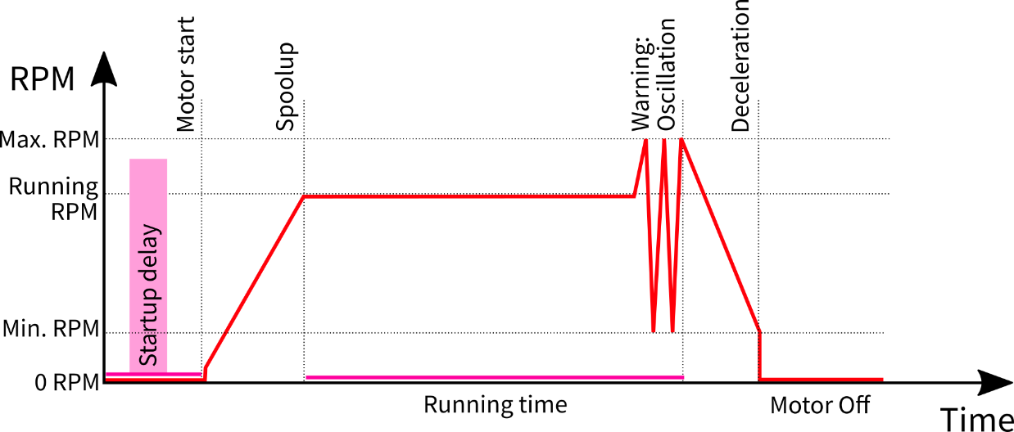

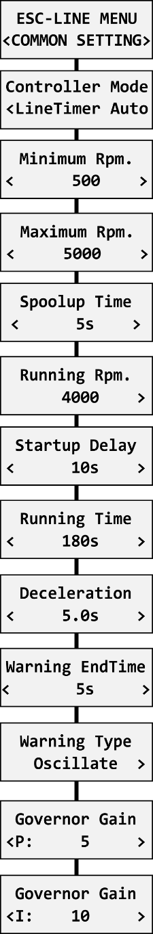
The Control-Line sequence is divided into several phases:
- Startup Delay: After power is applied, the controller remains at rest for a preset delay time. This gives the pilot time to prepare for the flight before the motor starts.
- Spool-Up: Defined by the Spool-Up Time parameter. During this phase, the motor gradually increases its RPM until the defined Running RPM value is reached. Once reached, the RPM is held constant.
- Flight Phase: The motor maintains constant RPM for the duration of the Running Time parameter. A warning can be configured to occur shortly before the end of the running time (Warning EndTime). Two warning types are available:
- Oscillate – The motor speed alternates between Minimum RPM and Maximum RPM.
- Set Maximum RPM – The motor switches to the speed defined by the Maximum RPM parameter, signaling that the end of the flight is approaching.
- Deceleration: At the end of the flight, the motor smoothly reduces RPM from the Running RPM down to the Minimum RPM. After reaching minimum, the motor is switched off completely.

Note: A new flight sequence can be started either by reapplying power to the controller or by pressing LEFT + RIGHT buttons simultaneously on the JETIBOX main screen.
Pressing LEFT + RIGHT at any time during operation also allows you to stop the current sequence immediately.
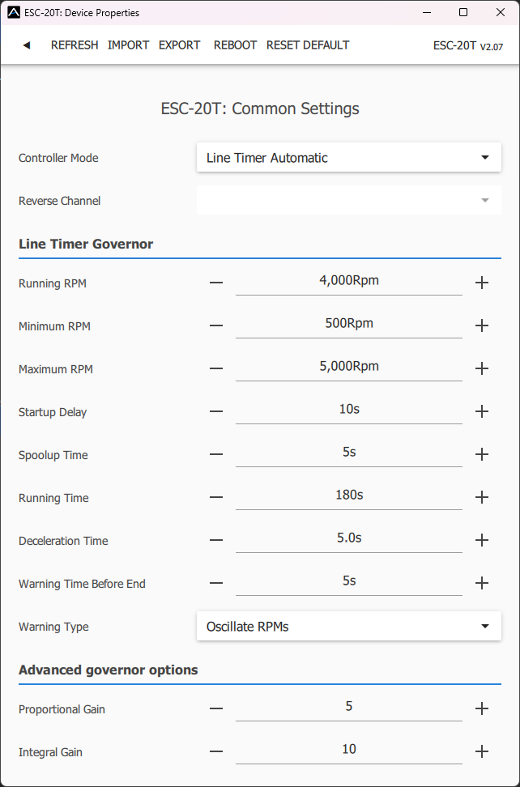
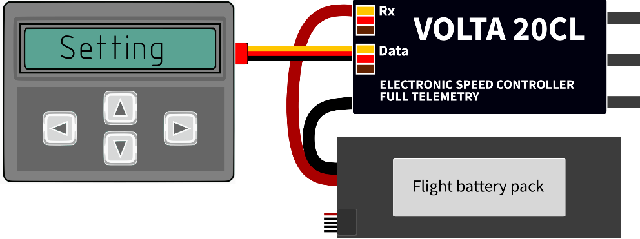

The VOLTA ESC is compatible with JETIBOX programming. The JETIBOX menu is divided into five sections:
- Actual values – displays the latest telemetry values together with minimums and maximums.
  - Available telemetry: Voltage, current, capacity, RPM, power (percent), temperature.
  - Reset Min/Max - press left+right buttons together to reset all minimums and maximums.
- Common settings – basic settings of the controller
  - Controller mode – basic controller mode.
  - Startup beep – choose a melody played after the controller initialization.
  - Standby beep – you can activate short repeated beeps as an indication of a powered motor drive.
  - Motor endpoints, motor start, motor full – settings related to throttle input signal decoding.
  - Capacity reset – you can choose at which moment the capacity and consumed energy are reset.
    - Power on – the capacity is cleared after initialization. However, the capacity from the previous run is shown initially, until you start the motor.
    - Voltage change – the capacity is cleared after you connect a battery with similar (or greater) voltage compared to the maximum battery voltage from the previous run. This means that each time you connect a fully charged battery of the same chemistry and number of cells, the capacity will be cleared.
    - Manual – the capacity/energy is never cleared and you must perform the reset manually.
  - Language – you can choose the language of the JETIBOX screen.
- Motor settings – settings related to motor parameters.
  - Direction, acceleration, timing, startup power, motor type, gear ratio, motor poles – see the Motor Settings chapter.
  - Brake related settings – see the Brake configuration chapter.
  - Freewheeling – enables freewheeling/active braking motor operation.
- Protection – ESC and battery protection settings.
  - Low battery – behavior when the battery is discharged. Either set to slowly reduce the motor power, or shut down the motor immediately. The minimum safe voltage is based on number of cells (cell count) and voltage per cell.
  - Limit current – enable this feature to prevent high current peaks and system overload.
  - Limit power at 100°C – you can edit the maximum allowed PWM after the controller temperature exceeds 100°C. The model must be operable, but the temperature must not increase anymore.
- Service – In this menu you can view the device version and reset it to the default factory configuration.

JETIBOX Menu Structure  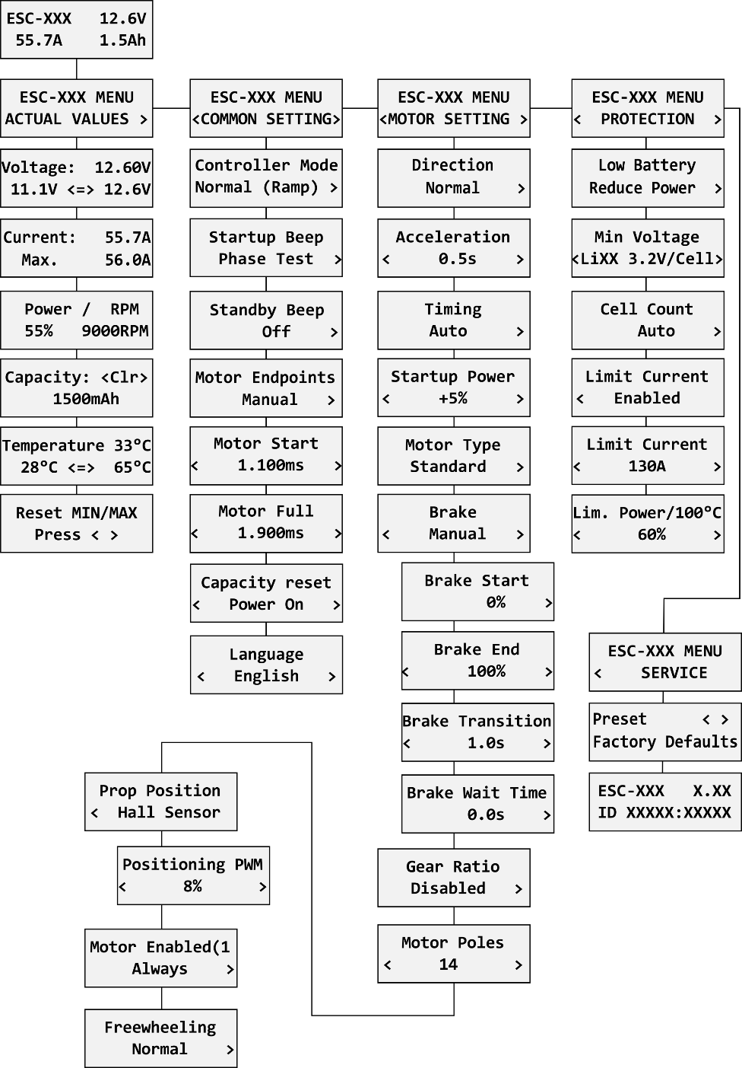 | Available EX and P²Bus telemetry  - Battery voltage [V]  - Motor current [A]  - Capacity [mAh]  - Speed [RPM]  - PWM [%]  - Power [W]  - Running time [s]  - Energy [Wmin] – useful feature for competitions where total energy is limited (F5B, F5D).  - Temperature [°C]  - Motor status:  0 = Initial state,  1 = motor running,  2 = braking
  Note: The propeller positioning and motor-enable functions are not available on the VOLTA 20 model.

Graupner Hott
The VOLTA CL controller is recognized by default as an “Air-ESC” sensor.
FrSky Integration
The controller is compatible with FPort and FBus capable receivers, allowing telemetry capabilities. The controller receives channel information and sends back telemetry data. It can decode all channel data from FBus 8 up to FBus 24, but only the first 16 channels can be used for internal functions.
Futaba and Multiplex connection
Futaba and Multiplex systems do not offer wireless device configuration. The telemetry transmission is possible with the following fixed sensor slots:
 | Futaba S.Bus2 slot | Note | Multiplex MSB slot
RPM | 2 | Choose RPM sensor on slot 2. |  | 6
Current | 3 | Choose SBS01C current sensor on slot 3. |  | 3
Voltage | 4 |  |  | 2
Capacity | 5 |  |  | 4
Temperature | 6 | Choose Temp125 sensor on slot 6. |  | 5
PWM (0-100%) | 7 | Choose Temp125 sensor on slot 7. |  | -
Motor temperature | - |  |  | 7
Note | Manual detection in the menu Linkage – Sensor. |  |  | Automatically detected by the transmitter.
PowerBox telemetry
The VOLTA CL controller is able to recognize the PowerBox P²Bus telemetry protocol. Connect the Telemetry cable (red connector) to the P²Bus port of the receiver. The transmitter scans for attached sensors as soon as the receiver is powered up and the controller telemetry should be available within 2.5 seconds. After that you are free to assign the telemetry to any desktop widgets and alarms. Available telemetry is similar to the Duplex EX telemetry (see above). The controller configuration through the PowerBox transmitter is not available at the moment.

Safety information
- Operate the VOLTA CL controller always in dry environment and within the device limits stated in this guide. Never expose the device to excessive heat or cold outside the working area.
- Provide sufficient airflow to prevent controller overheating.
- Never exceed the maximum allowed operating voltage of the controller/motor.
- Do not increase the cable length between the controller and motor. If you need to extend the wires between the controller and the battery to more than 30 cm (in total), solder multiple high-capacity Low-ESR capacitors (220-470uF) in parallel to the power wires as close to the controller as possible. For each centimeter beyond the specified cable length, add a capacitance of 1uF for every ampere of current passing through. For example, if you exceed the limit by 10 cm with a current of 100A, solder a 1000uF capacitors pack.
- Always use high quality connectors in good condition. Replace them if any visible sign of wearing appears.
- Always remove the propeller prior to making any changes in drive setup.
- Never disconnect the ESC from the battery while the motor is spinning.
- Do not remove the cover and heat sink from the device and do not try to implement any changes or modifications. This can lead to a total destruction and to the denial of any warranty claims.
- Always check the polarity of the connection. Never inverse the polarity – this could lead to total destruction.

Firmware Update
Firmware updates for the VOLTA CL ESC are transferred from a PC via the USB interface. The required programs and files are available at www.mavsense.com.
Install the MAV Manager software and the USB drivers on your computer. Check the system requirements.
- Make sure that the battery flight pack is disconnected and the VOLTA CL ESC is unpowered.
- Connect the USB interface to your PC, run MAV Manager - Updater and select the correct COM Port.
- Connect the VOLTA CL ESC according to the picture below – use the red (telemetry) port. The controller will be automatically detected.
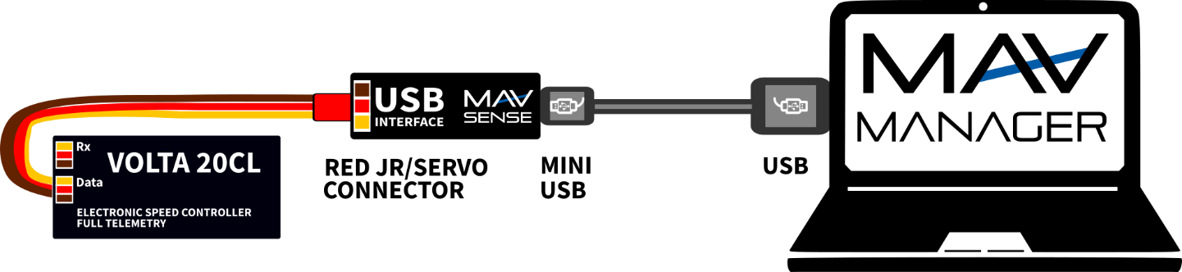
- Select the correct *.BIN file and press the Update button.

PC configuration
It is possible to use the MAV Manager software (1.16.0 and later) to conveniently configure all controller settings, display real-time telemetry and make a backup of the configuration. The configuration menu contains four buttons in the top toolbar:
- Refresh – forces the configuration to be reloaded from the controller.
- Import – imports the settings from a file. If you have several speed controllers and want identical settings for all of them, simply import the same settings to each controller.
- Export – exports the settings from the controller to a file. You can easily create a backup configuration stored in your PC. After creating a backup, you may easily experiment with the controller settings and later revert back to the original configuration by pressing the “Import” button and choosing the original exported file.
- Reset default – resets the controller to factory defaults and reloads all the settings.
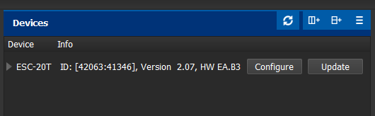  Connect the controller to your PC using the USB interface. The ESC will be automatically detected by the MAV Manager. | 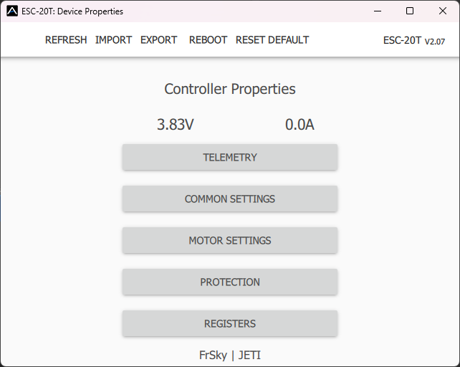  The controller properties are available after pressing the “Configure” button.
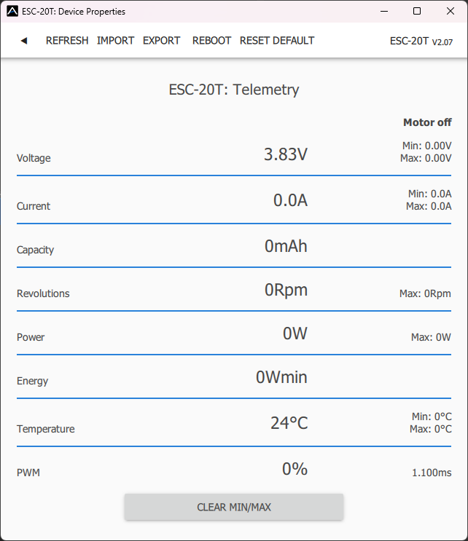  Real-time telemetry with min/max values. The MAV Manager is also able to create a log file from the real-time telemetry data, which can be viewed, analyzed, imported and exported. | 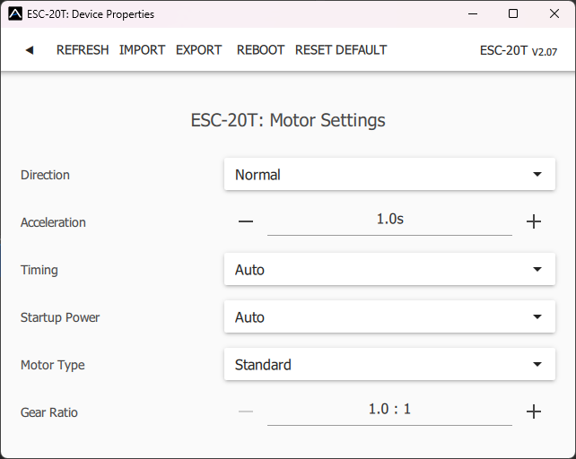  Motor settings. Every time you make any change in the configuration, the new value is immediately transferred to the controller and saved to memory. There is no need for additional confirmation. For safety reasons, some parameters are only applied after the motor is stopped.

Warranty

We grant a warranty of 24 months from the day of purchase under the assumption that they have been operated in conformity with these instructions at recommended voltages and that they were not damaged mechanically. Warranty and post warranty service is provided by the manufacturer.

Manufacturer
MAV Sense s.r.o.
E-mail: info@mavsense.com | Website: www.mavsense.com

